Summative Assignment: (DATA2A)
Database Development 2
For Learner Use:
Surname of Learner | Langa
Name of Learner | Thulani
Learner ID | 0308175686085
Student Number | TLPMB044
Date of Test Given | 24/07/2024

For Assessors Use:
Name of Facilitator

Name of Assessor

Mark Allocation | 200
Mark Obtained

Competency Status (C / NYC)

Knowledge and Practical Outcomes Assessed
119458 Occupational Certificate: Software Engineer | - 251201-001-00-00-KM-03, Database design and Information Systems, NQF Level 6, Credits 15  - 251201-001-00-00-PM-02, Design and Manipulate Databases, NQF Level 5, Credits 5

Candidates Signature |  | Date of Submission
Assessors Signature |  | Date Marked

Instructions:
- Complete the assignment using SQL statements and scripts on an SQL database.
- Read each question carefully and answer all questions.
- Place screenshots in the space provided.
- Write answers in the space provided.
- Complete the cover page in full.
- Plagiarism will not be tolerated.
- Ensure your work is formatted neatly and readable by the Assessor at all times.
- Submit one complete assignment in an editable format.
- Any attachments must be submitted with the original submission.

Competency Ratings:
- Not Yet Competent (NYC) – Student achieves less than 60%
- Competent (C) – Student achieves 60% – 74%
- Competent with Merit (C/M) – Student achieves 75% - 84%
- Competent with Distinction (C/D) – Student achieves 85% - 100%

Please ask for assistance from your Assessor, should you require it, to install SQL on your machine in working order!

Scenario
You have been tasked with implementing SQL queries to satisfy the business requirements of TechCorp Solutions, a leading global technology consulting company.

These requirements are divided across various departments:
- Finance
- Human Resources
- Database Administration

Your task is to write SQL queries to support business operations, including advanced reporting, data manipulation, and table maintenance tasks.

This assessment requires you to create complex queries that not only return correct results but are also optimized for efficiency, handling of large datasets, and edge cases.

You must:
- Write SQL scripts to satisfy each requirement.
- Prepare a Test Plan to describe how you will test each query.
- Maintain a Test Log that documents the testing process.
- Provide Evidence of Testing including screenshots or printouts of query results and executions.

Submission Guidelines:
- SQL Script: For the SQL queries, provide a SQL script file named TC.
- Test Plan: Provide a detailed Test Plan as a separate document, including test cases and expected results.
- Test Log: Document all your testing steps in a Test Log. Ensure the log includes all test results and any issues encountered.
- Evidence of Testing: Include screenshots or output files showing the SQL query executions and their results.

Section 1: Theoretical Questions
Question 1: Introduction to Information Systems [10]
  - Define an information system and explain its role in modern organizations.
An Information System (IS) is an interconnected system involving but limited to people, data, technology and processes that collect, process, store and distribute information

(2)
  - Differentiate between data and information with relevant examples.
Data refers to the raw, unprocessed facts, figures or observations without any inherent meaning (e.g., “69”, “Doja”, “Artist”). Information is the processed data itself that has been processed, organized, and contextualized to become meaningful.

(2)
  - List and describe three types of information systems commonly used in organizations.
Transaction Processing System (TPS): Handles routine, day to day transactions at the operational level.
Office Automation System (OAS): Improves the communication for office workers and increases productivity.
Knowledge Work Systems (KWS): Used as a way to help workers in creating solutions and solving complex problems and creating new knowledge.

(3)
  - Explain the relationship between management levels and different types of information systems. Provide one example of an information system used at each level.
MIS serve the crucial function of middle management and these systems draw their data primarily from the operational-level TPS and uses it to manage daily tasks (e.g., Payroll System), Management level uses MIS to make departmental decisions (e.g. Budget tracking system), and the Strategic level uses DSS or EIS for long-term planning (e.g. Dashboard).

(3)

Question 2: Components of an Information System [10]
  - Identify and describe the key hardware components of an information system.
Input & Output Devices: Capture and present data
Processing Devices: Process data and execute instructions
Storage Devices: Stores data permanently
Network Devices: Enable communication and data transfer between devices

(3)
  - Differentiate between system software and application software, providing two examples of each.
System Software controls hardware, provides a platform for applications and manages the computer’s resources (e.g., Windows Operating System) whilst Application Software performs specific user tasks.

(3)
  - Explain how people and procedures influence the functioning of an information system.
Human people are indispensable to any Information Systems as the human people are individuals that interact the systems, providing inputs and interpret output. Procedures are rules that guide system use, they define how the components work together and ensure consistency, efficiency and compliance.

(2)
  - Define a network and explain the key differences between LAN, WAN, and MAN.
A network is a group of interconnected devices enabling communication and data transfer between devices. There are different types of computer networks categorized by their geographical scope:
- LAN: Covers a small area like an office or home
- WAN: Covers a city or campus
- MAN: Cover Larger geographical areas

(2)

Question 3: Principles of Database Design [20]
  - Explain three different database design approaches.
Database design is the systematic process of structuring data to meet the information needs of an organization, database design can be categorized but not limited by these three approaches:
- Top-Down Design: Starts from the business perspective and defines data requirements.
- Bottom-up Design: Begins with specific data elements and builds upward to form the database.
- Centralized Design: Presumes that all the user requirements and data needs for the entire database system can be gathered and analysed by a single design team.

(3)
  - Outline the key phases of database design and describe the role of normalization in the process.
The key phases of database design regardless of the approach are as follows:
- Requirement Analysis
- Conceptual, logical and Physical Design
- User Needs
- Existing Systems (if applicable)
- Performance Expectations
- Security and Compliance requirements

Normalization is crucial for relational logical design, and organizes data to reduce redundancy and improve data integrity, typically using rules from 1NF, 2NF, 3NF, etc.

(5)
  - Describe the theory of data modeling and list three common data modeling techniques.
Data Modelling defines how data is structured and related. It helps in designing databases that reflect real-world entities.

(4)
  - Illustrate how an Entity-Relationship Diagram (ERD) can be used to design a database.
To properly illustrate how an ERD can be used to design a database, I will use a simple library database. A member can borrow many books, and a book can be borrowed by many members over time. The entities to keep track of are as follows:
- Books
- Members
- Loans

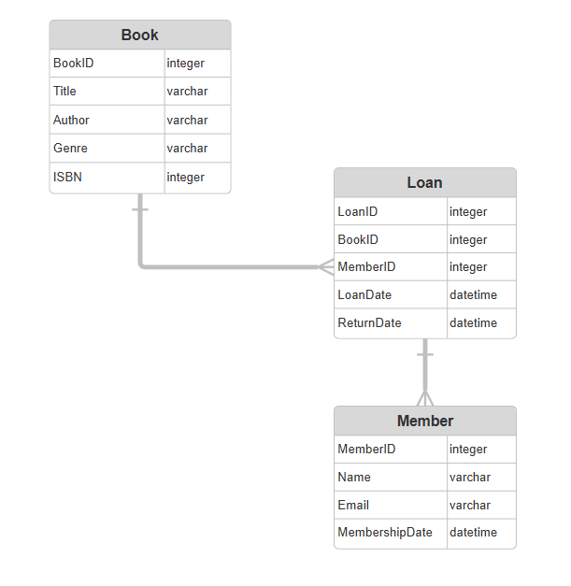
(4)
  - Explain the difference between a conceptual, logical, and physical data model.
Different levels of abstraction in database design are represented by conceptual, logical, and physical data models. Physical models describe how the data will be stored in a particular database system, logical models specify the structure of data in terms of entities and attributes, and conceptual models concentrate on high-level business concepts and relationships.
- Conceptual model: High-level view using ERD, abstracts away the technical details.
- Logical model: Adds attributes, data types, and normalization, by transforming conceptual model into a logical schema based on a chosen database model.
- Physical model: Actual SQL tables indexes, and storage settings, the logical schema is then optimized for a specific DMBS and hardware environment.

(4)

Total Section A: [40]

Section 2: Practical SQL Queries
These queries align with real-world business scenarios and database development concepts. Please provide screenshots along with queries in your response.
Question 4: Database Design and Creation [20]
  - Write SQL scripts to:
  - Create a database called TechCorpDB. (2)
  - Create three tables: Employees, Departments, and Salaries, ensuring proper data types and constraints. (6)
  - Insert sample data into these tables (at least five records per table). (6)
  - Modify the Employees table by adding a new column called Employee_Status (Active/Inactive). (3)
  - Remove the Employee_Status column from the Employees table. (3)

Finance and Accounting Department Queries [30]
  - Write SQL scripts to:
- Retrieve employees who earn above 120% of the department’s average salary but were hired before January 1, 2020. (4)
- Calculate and return department-wise employee turnover rates. (4)
- Compute the median salary for each job title, rounding to the nearest whole number. (4)
- List the five highest-paid employees from "Technology" or "Finance" departments. (4)
- Identify employees who have worked at the company for over 10 years. (4)
- Calculate the total payroll expenditure per department. (5)
- Identify departments where no employees have left in the past 12 months. (5)

Talent Acquisition Queries [30]
  - Write SQL scripts to:
- List departments that have more than 50 employees but an average salary below 4000. (4)
- Find departments where the number of high-salary employees (>7000) is greater than low-salary employees (<3000). (4)
- Increase salaries by 10% for employees who have been at the company for more than five years and currently earn more than 4000. (4)
- Identify employees eligible for retirement (age ≥ 60). (4)
- Count employees who have worked in multiple departments. (4)
- Identify the longest-serving employee in each department. (5)
- Find employees who have never taken a leave of absence. (5)

System Administration Queries [30]
  - Write SQL scripts to:
- Create a table called EMPLOYEE_AUDIT to track changes in the Employees table. (5)
- Insert a new record into EMPLOYEE_AUDIT whenever an employee’s salary is updated. (5)
- Identify employees without a manager (manager_id is NULL). (4)
- Delete all records from EMPLOYEE_AUDIT where the change happened before January 1, 2021. (4)
- Backup the Employees table into EMPLOYEES_BACKUP without data duplication. (4)
- List employees whose last name starts with "K" and work in the Marketing department. (4)
- Implement database indexing on Employees table to optimize search performance. (4)

Total Section B: [140]

Section 3
Question 5: Testing and Documentation [40]
  - Prepare a test plan for testing the SQL queries following these guidelines: (15)
- Describe the strategy for testing each query.
- Identify edge cases such as NULL values or invalid dates.
- Outline expected results for each query.

  - Using your test plan, provide a test log comparing actual vs expected results: (15)
- Document each query’s testing process.
- Compare expected vs actual outputs.
- Address any discrepancies.

  - Provide evidence of testing, including screenshots or output files showing SQL query executions. (10)

Total Section C: [40]
Total Marks: 200

